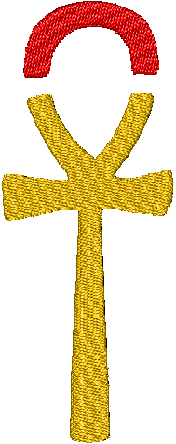

I have 12 designs and ideas that are done roughly and would like them to be done professionally for my clothing line.

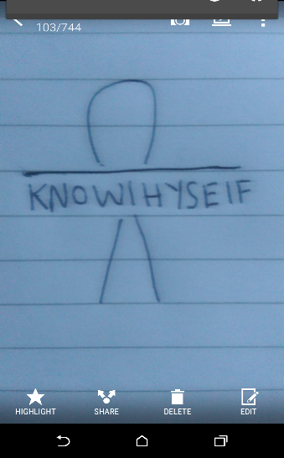

Logo 1-The first image is the brand logo-with the **Ankh** cut short with the letters “KNOW THYSELF“ under it in bold.

Colour-black

-Notice gap.

-Notice ”THYSELF” isn’t as bold.

This image will be used for the back of top, under the neck.

You can mess around with the colour of the top of the ankh.

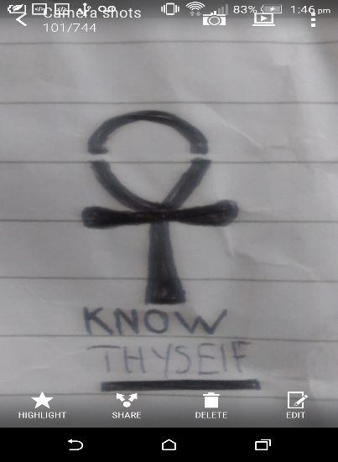

Logo 2-This image will be shown large on the back of the Shirt.

-Notice the letter T in the being in the middle. (bad example).

You can mess around with the colour and width of the lines (or make it look 3d).

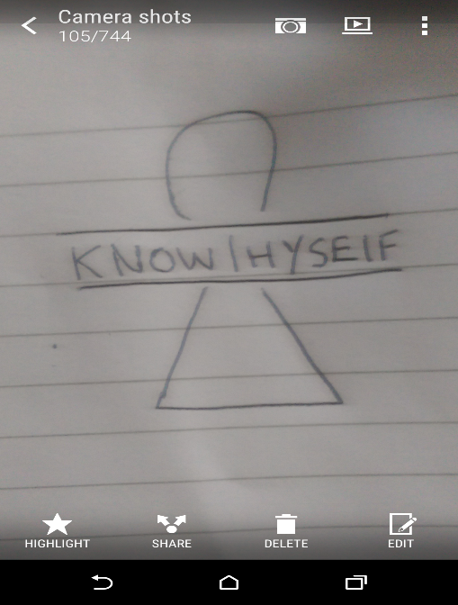

Logo 3-This image will be shown large on the back of the Shirt. notice the letter T in the middle again.

You can mess around with the colour and width of the lines (or make it look 3d.

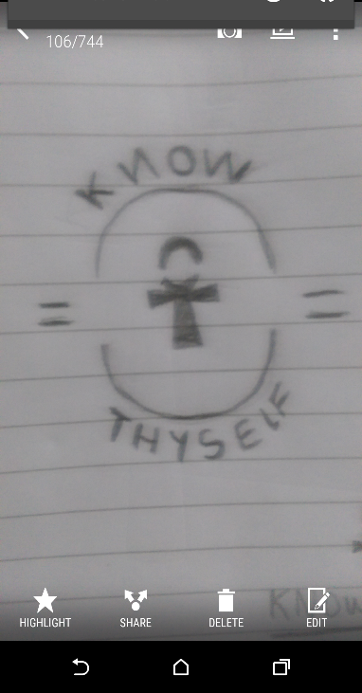

Logo 4-this image will be on shown large on the back.

The lines are darker or lighter than the writing and ankh.

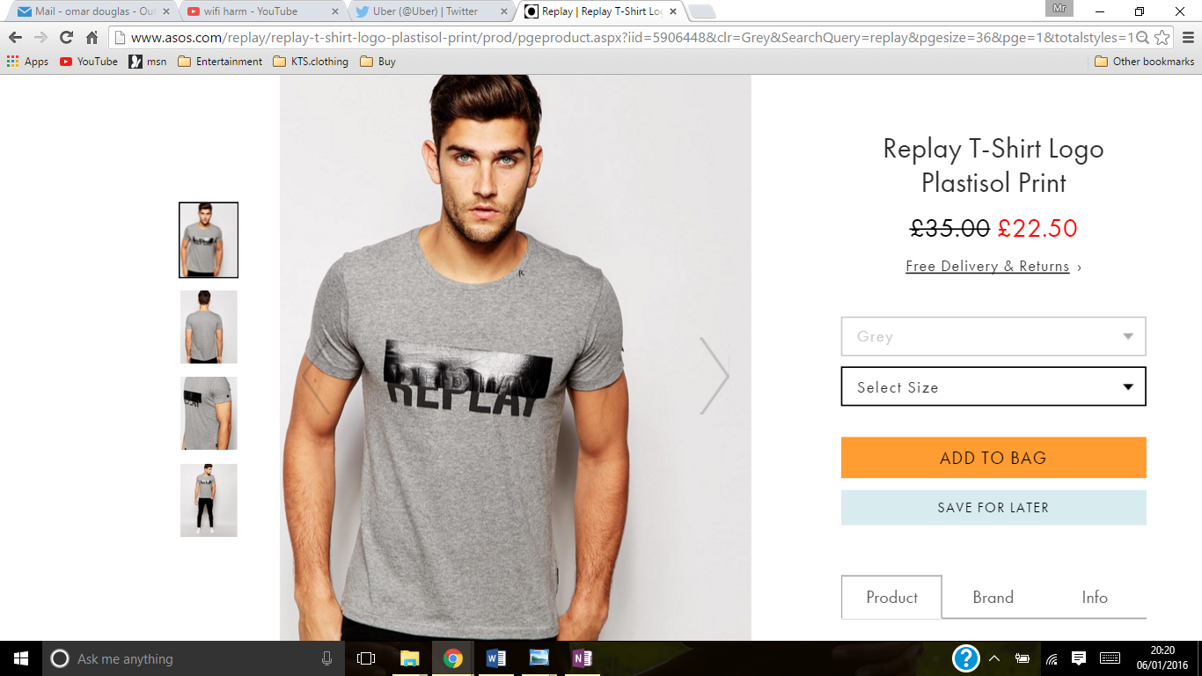

Image 6 and 7 like the picture on the left <<but the letters “know thyself” going down on the side of the image for image 6.

**With all images tinted black and white.**

Not to be done as logo ,only example.!

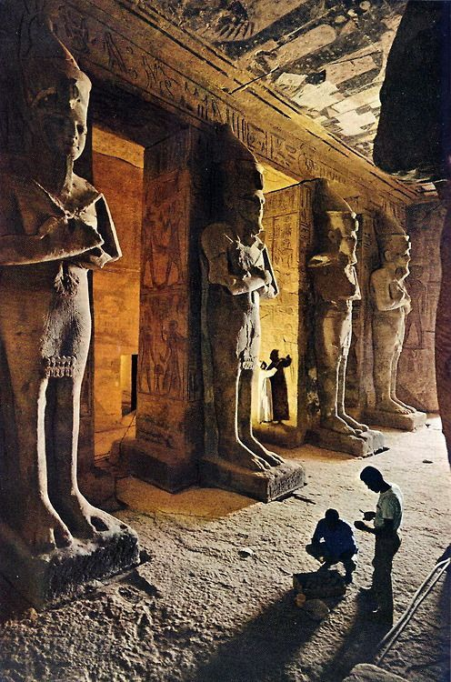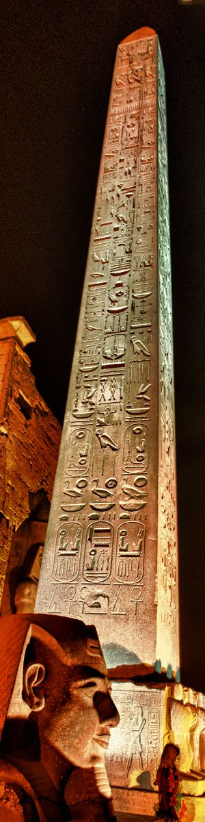

Image 7

Image 6

This image 8 on the left is for the shoulder and arm of the t shirt. The **cartouche.**

with this outline . vvv

**Plain in black and white**

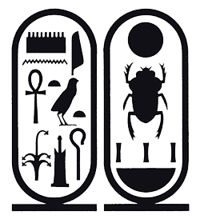

Image 8

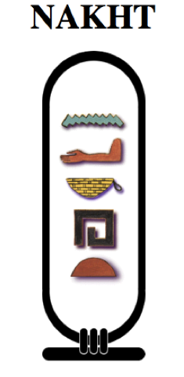

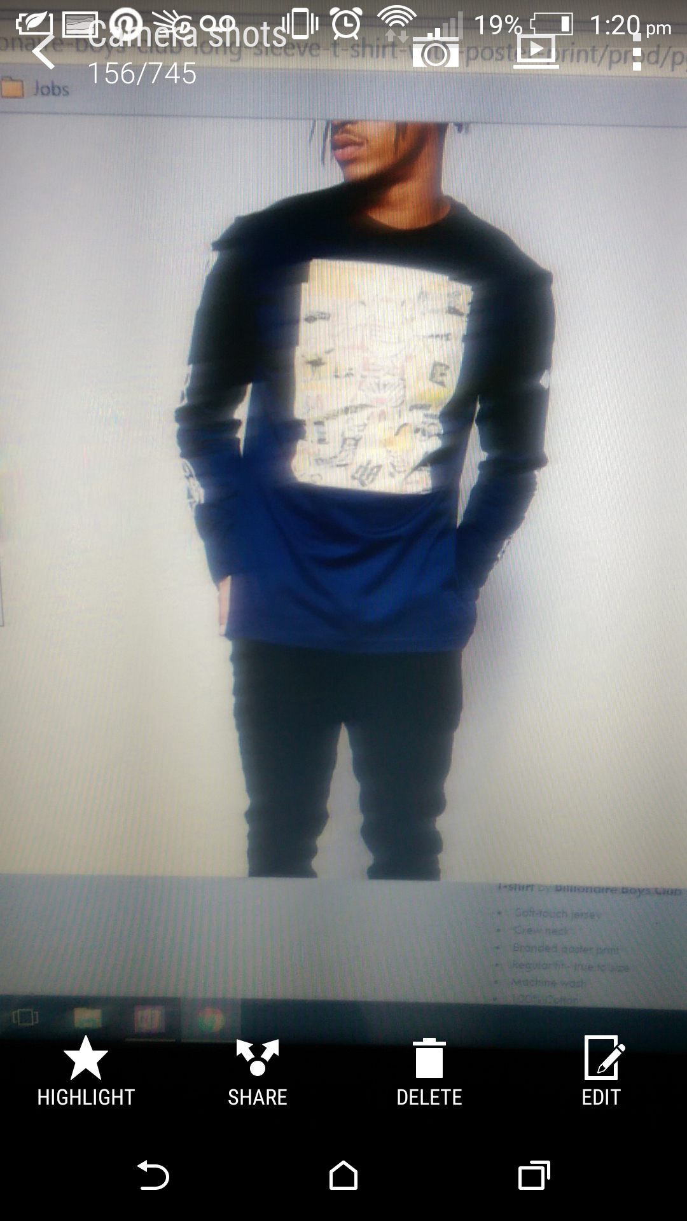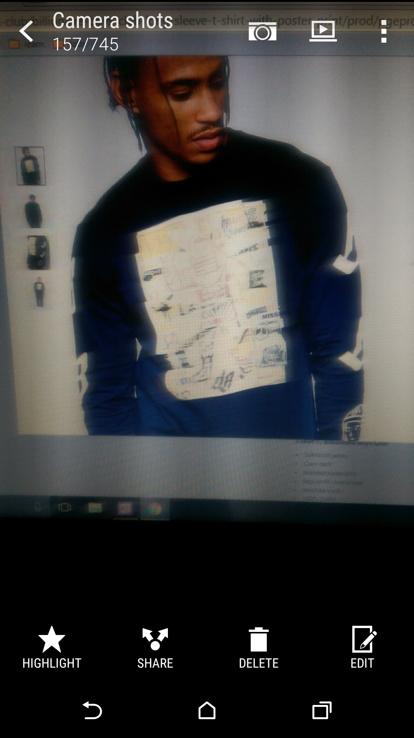

I am aware these photos are blurry but the way these images are done they have a newspaper, cut up into squares feel too it can this be done to image

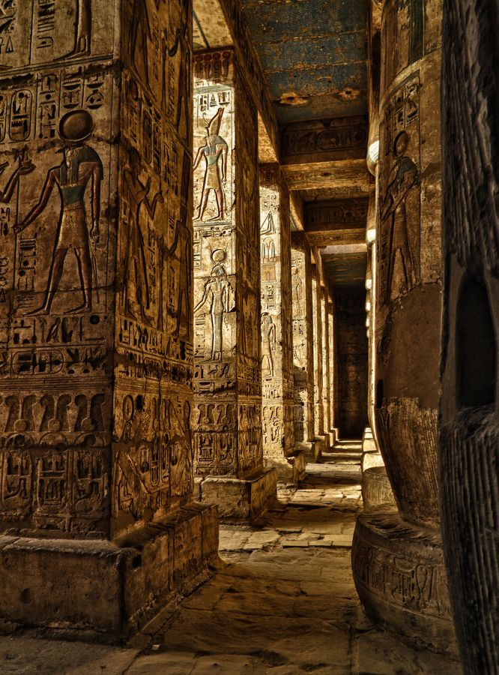

Image 9

Image 10

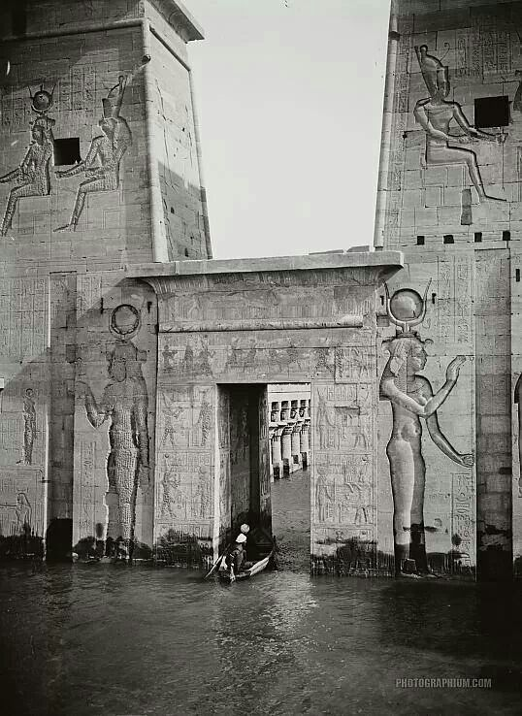

Image 11

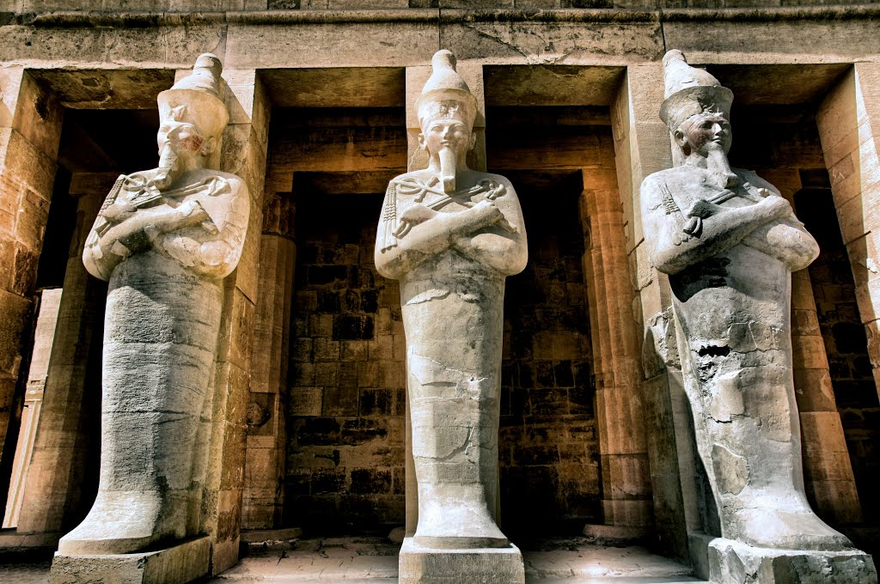

Image 12

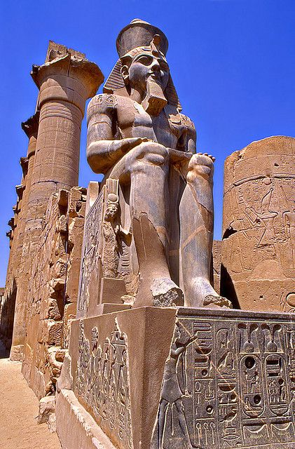

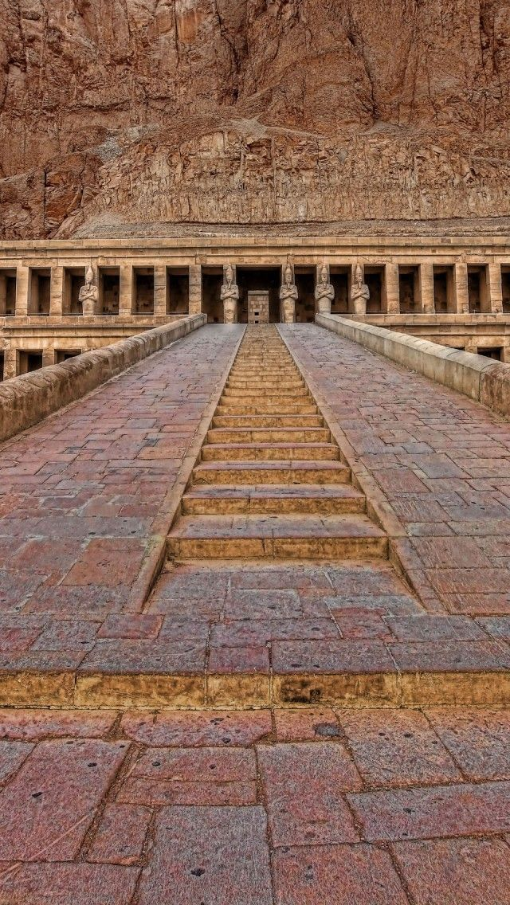

Image 13